Auto Import Library to the Framework
(Auto Config Bean)

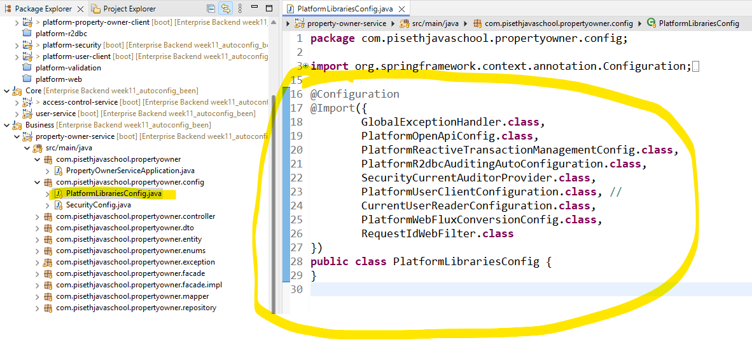

កន្លែងដែលបង្កើត Config to create been for the project (import module):
គោលបំណង់គឺយើងគ្រាន់តែដាក់ Dependancy អោយវាដើរតែម្តង មិនចាំបាច់ មកធ្វើ Manual import ទេ។
- Click on the platform that we want to create autoconfig

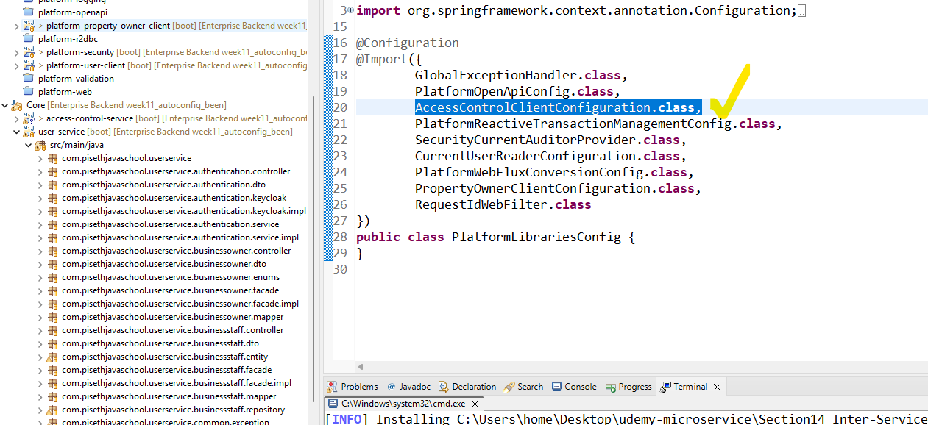

Then it will go to that class:

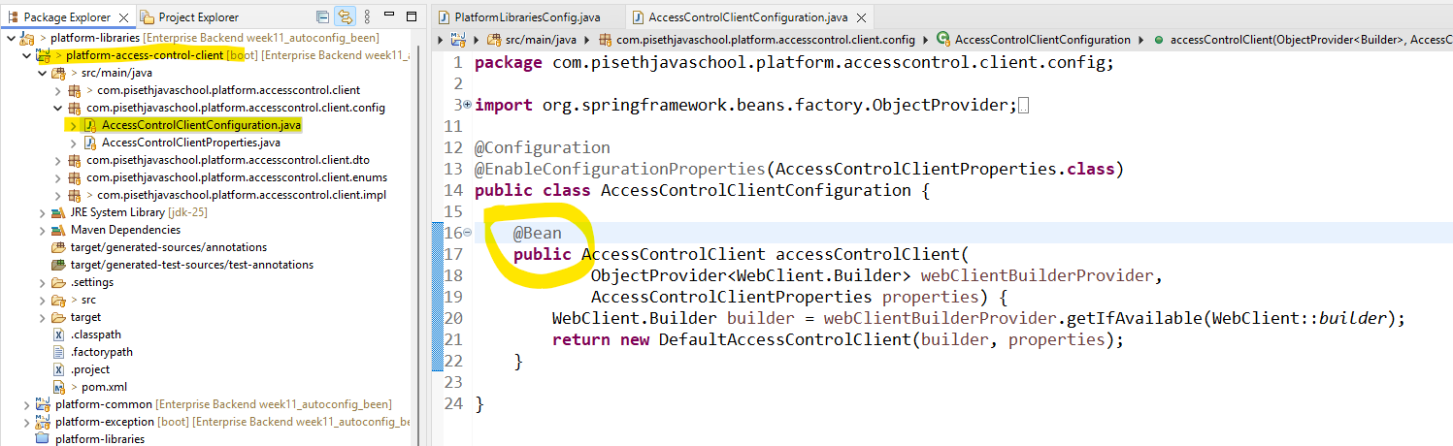

កន្លែងនឹងវាទាក់ទងទៅនឹង concept spring core ការបង្កើត Bean
- Create folder to keep the auto config

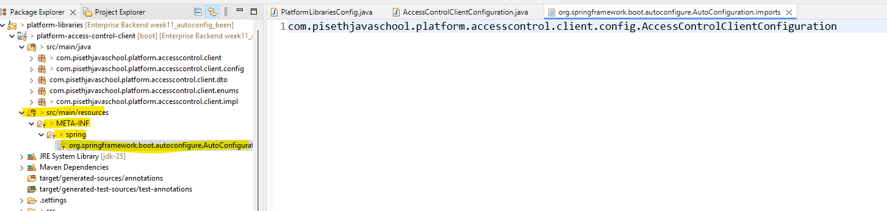

platform-access-control-client/src/main/resources/META-INF/spring/org.springframework.boot.autoconfigure.AutoConfiguration.imports

- The paste the file where we want them to create autoconfig create bean:

Then add the @ AutoConfiguration to that class:

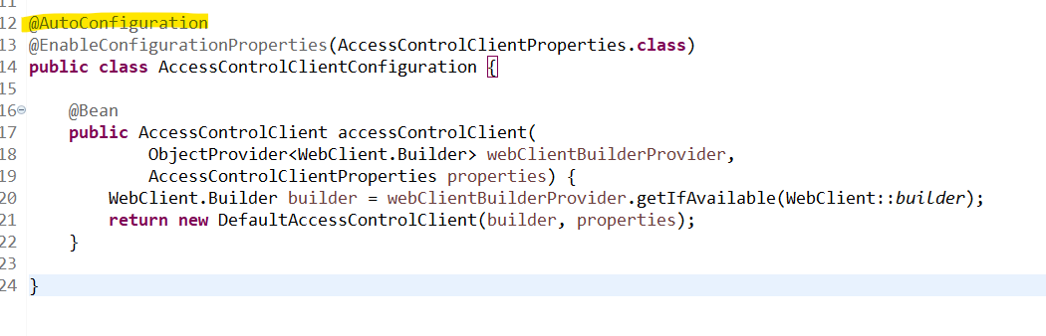

@Bean
@ConditionalOnBean(PlatformUserIdResolver.class)
@ConditionalOnMissingBean(CurrentAuditorProvider.class)
public CurrentAuditorProvider securityCurrentAuditorProvider(PlatformUserIdResolver resolver) {
return new SecurityCurrentAuditorProvider(resolver);
}

@Bean
@ConditionalOnMissingBean // NEW
public CurrentUserReader currentUserReader(CurrentAuditorProvider currentAuditorProvider) {
return new CurrentUserReader(currentAuditorProvider);
}

Note to have condition :

@ConditionalOnBean(PlatformUserIdResolver.class)
@ConditionalOnMissingBean(CurrentAuditorProvider.class)

ប្រាប់វាថាទាល់តែមាន PlatformUserIdResolver.class បានបង្កើត អាក្រោមនឹងបាន CurrentAuditorProvider.class

យើងធ្វើចឹងដើម្បីបង្ការ កុំអោយមានបញ្ហាពេល StartUp

